Job Title: | Project Support Officer
Department: | Customer Strategy and Insights
Reports to: | Principal Community Incident and support Officer
Direct Reports: | N/A
Location: | Activity Based On Site
Contract Type: | Temporary until December 2027
Grade: | CA4

Main purpose of the job

Provide practical process and administrative support to the Incident Response project. Working closely with incident response account managers and colleagues, you will gather and organise information, record agreed ways of working, and turn these into clear guidance and process flows. You will check that responsibilities, hand-offs and key dependencies are accurately captured, keeping documents up to date as the project develops. This temporary role requires flexibility, strong organisational skills and close attention to detail.

Responsibilities

Specific
- Support incident response account managers and project colleagues to identify and keep track of the processes and supporting documents needed for effective incident response.
- Gather information from colleagues and stakeholders, ask questions to fill in missing detail and record agreed responsibilities and ways of working.
- Review the information provided, ask sensible questions and highlight any gaps, repeated steps, dependencies or unclear hand-offs for the project team to consider.
- Translate complex or evolving requirements into clear, concise and accessible plain-English process documentation.
- Create and keep clear process maps and flows up to date in Microsoft Visio, showing the agreed steps, responsibilities and hand-offs.
- Share draft process documents with relevant colleagues, bring together their feedback and make agreed changes so the final versions are clear and practical to use.
- Maintain appropriate version control and an organised record of agreed processes, decisions and supporting information.
- Adapt priorities and documentation quickly as project requirements change, while maintaining accuracy and quality.
- Provide regular progress updates, follow up missing information and bring any gaps, risks or decisions that may affect delivery to the attention of the relevant account manager or project lead.

General
- Act in line with the behaviours and values of the organisation.
- Manage your own performance to be accountable for meeting individual, team and corporate objectives.
- Act in accordance with the Scheme of Delegation and ensure propriety and regularity in the handling of public funds.
- Actively demonstrate the Mining Remediation Authority’s customer service standards expected of your role.
- Follow and contribute to the improvement of operational and team processes and procedures.
- Assist with the preparation and delivery of the team’s objectives, budgets and financial records.
- Identify opportunities and implement change leading to team development, system. improvement and ensuring good value for money.
- Maintain and develop positive stakeholder relationships in order to promote the Authority and assist it to meet its objectives.
- Support research and development projects.
- Ensure that the Authority’s statutory responsibilities are effectively discharged.
- Carry out any further reasonable requests from your line manager.

Values in Action
We expect all our colleagues to embody our core values and behaviours in their daily work.
Trusted
- We act with integrity
- We’re open and transparent
- We deliver on our commitments
Inclusive
- We promote a culture of mutual respect
- We recognise that our differences make us stronger
- We work with others to achieve our vision
Progressive
- We’re open minded and innovative
- We recognise that the past can help us shape the future
- We listen and learn
Our Values in Action framework outlines important behavioural indicators which help us demonstrate our values through our work together.

Hybrid Working Model
This role sits within our Hybrid Working Model. The designated hybrid arrangement for this post is outlined under “Location” on page 1 of this Job Description and reflects the requirements of the role and the organisation. Hybrid working arrangements may be reviewed and adjusted if business needs change.
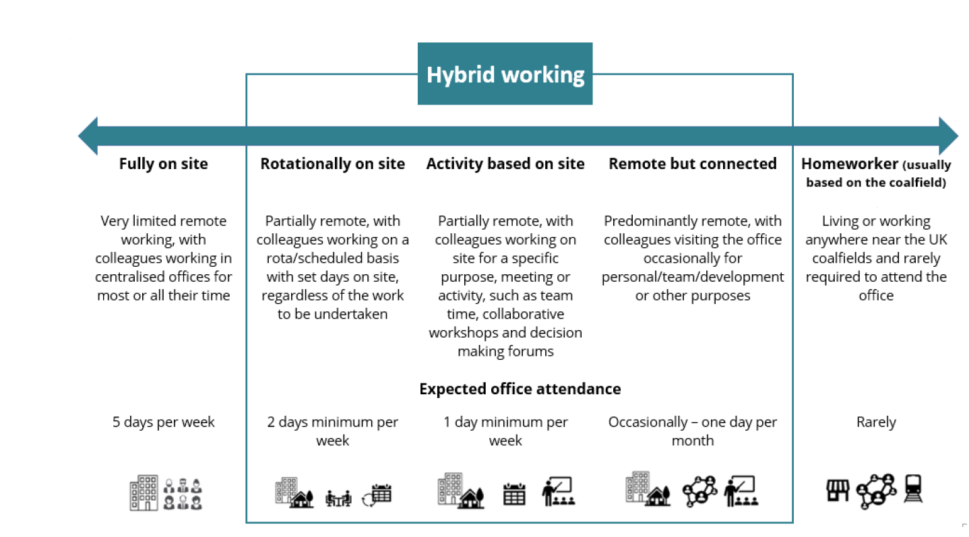

Person specification

Job Title: | Project Support Officer |  | Department: |  | Customer Strategy and Insights
 | Essential |  | Desirable
Qualifications and Training | - Good general education, or equivalent experience gained in an administrative, project support or operational support role. |  | - Training in project administration, process mapping, document control or a related area.
Experience and Knowledge | - Experience in an administrative, project support, customer service or operational support role.  - Experience of gathering information from colleagues and turning it into clear, well-organised documents.  - Experience of keeping records, trackers or guidance accurate and up to date.  - Experience of managing different tasks, following up outstanding information and meeting deadlines.  - Experience of working with colleagues or stakeholders to clarify information and support agreed ways of working. |  | - Experience of supporting a busy project, customer-facing service or team where priorities change quickly.  - Experience of creating simple process maps, workflow diagrams or step-by-step guidance.  - Awareness of document control or version control.
Skills and Abilities | - Able to organise information and present it clearly in plain English.  - Good attention to detail, with the ability to check information for accuracy and spot missing or unclear details.  - Clear and confident communication skills, including asking questions and following up when more information is needed.  - Able to organise your own workload, keep track of actions and meet deadlines.  - Able to adapt when priorities change while continuing to work carefully and accurately.  - Competent in Microsoft 365 applications, with experience of Microsoft Visio or another process-mapping tool, or the ability to learn it quickly. |  | - Able to create clear process maps or workflow diagrams.  - Able to produce clear guidance for different audiences.  - Able to take clear notes and record actions from meetings or discussions.
Other | - A helpful, organised and flexible approach, with a willingness to support colleagues and adapt as priorities change. |  | - Understanding of incident management or customer-facing service environments.
 |  |  |  | 

