Job Title: | Community Incident & Support Advisors
Department: | Community Incident Management and Support
Reports to: | Community Incident & Support Team Manager
Direct Reports: | None
Location: | Rotational on site
Contract Type: | Temporary
Grade: | CA4

Main purpose of the job

As a Community Incident & Support Advisor, you will provide a responsive, empathetic and professional first point of contact for residents affected by incidents. Working across telephone and email you will assess resident needs, record accurate information, provide clear advice, support safe and timely escalation, and keep residents informed throughout the incident response process. You will play a vital role in protecting resident confidence, supporting effective incident management and ensuring residents receive a consistent, compassionate and high-quality service.
Responsibilities

Specific
- You will act as a first point of contact for residents during incidents, urgent service issues and high-priority enquiries, providing clear, calm and accurate information.
- You will gather, verify and record incident details accurately using relevant systems, ensuring information is complete, timely and suitable for escalation or follow-up.
- You will triage resident enquiries, assess urgency and risk, and escalate complex, technical or safety-related matters through the appropriate incident response routes.
- You will provide reassurance and practical support to residents who may be distressed, vulnerable or affected by disruption, using empathy, patience and positive communication.
- You will maintain regular communication with residents and internal teams to provide updates, manage expectations and support a coordinated response.
- You will follow agreed incident response procedures, service standards and escalation protocols to support safe, consistent and timely outcomes.
- You will manage resident service mailboxes within agreed service levels, ensuring urgent incident-related messages are identified and handled promptly.
- You will identify and record complaints, expressions of dissatisfaction, compliments and lessons learned to support service improvement following incidents.
- You will build positive and professional relationships with residents, colleagues and partner organisations, promoting confidence in the organisation’s incident response service.
- You will handle personal, sensitive and incident-related information with discretion, confidentiality and in line with relevant policies and procedures.
- You will support post-incident review activity and support the account managers by sharing resident insight, identifying recurring issues and contributing to improvements in resident communications and processes.
- Identify where vulnerable customers may need additional support and prioritise.

General
- Act in line with the behaviours and values of the organisation.
- Manage your own performance to be accountable for meeting individual, team and corporate objectives.
- Act in accordance with the Scheme of Delegation and ensure propriety and regularity in the handling of public funds.
- Actively demonstrate the Mining Remediation Authority’s customer service standards expected of your role.
- Follow and contribute to the improvement of operational and team processes and procedures.
- Assist with the preparation and delivery of the team’s objectives, budgets and financial records.
- Identify opportunities and implement change leading to team development, system. improvement and ensuring good value for money.
- Maintain and develop positive stakeholder relationships in order to promote the Authority and assist it to meet its objectives.
- Support research and development projects.
- Ensure that the Authority’s statutory responsibilities are effectively discharged.
- Carry out any further reasonable requests from your line manager.

Values in Action
We expect all our colleagues to embody our core values and behaviours in their daily work.
Trusted
- We act with integrity
- We’re open and transparent
- We deliver on our commitments
Inclusive
- We promote a culture of mutual respect
- We recognise that our differences make us stronger
- We work with others to achieve our vision
Progressive
- We’re open minded and innovative
- We recognise that the past can help us shape the future
- We listen and learn
Our Values in Action framework outlines important behavioural indicators which help us demonstrate our values through our work together.
Hybrid Working Model
This role sits within our Hybrid Working Model. The designated hybrid arrangement for this post is outlined under “Location” on page 1 of this Job Description and reflects the requirements of the role and the organisation. Hybrid working arrangements may be reviewed and adjusted if business needs change.
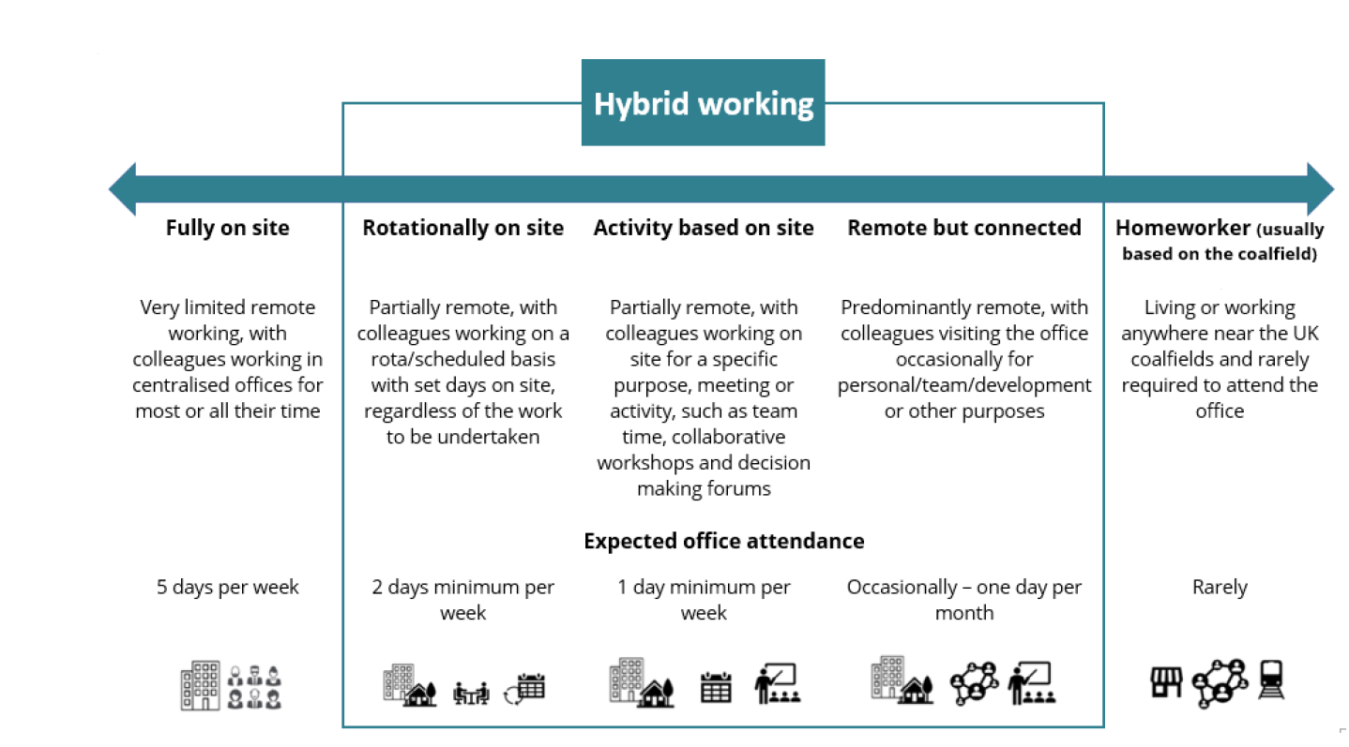

Person specification

Job Title: Community Incident & Support Manager |  | Department: Community Incident Management & Support
 | Essential | Desirable
Qualifications and Training | - (No minimum qualification set if candidate can demonstrate relevant experience required for the role) | - GCSEs at Grade C and above to include English and Maths  - NVQ diploma or equivalent in customer service  - Proficient in excel
Experience and Knowledge | - Previous experience in a customer service environment  - Experience of using Microsoft Office, including teams and excel  - Experience of front-line customer service provision through a variety of access channels  - Experience of managing challenging customers | - Experience of incident response situations
Skills and Abilities | - Excellent written and verbal communication skills  - Excellent time management skills and ability to multi-task and prioritise work  - Excellent listening skills  - Ability to use positive language  - Ability to demonstrate patience and empathy  - Ability to work under pressure

