Job Title: | Project Manager - Innovation By-Products and Service Delivery
Department: | Innovation, By-Product and Services Delivery
Reports to: | Principal Heat and By-Product Manager
Direct Reports: | None
Location: | Remote but connected
Contract Type: | Temporary
Grade: | CA5

Main purpose of the job

- To lead the identification, implementation and delivery of Innovation related projects, such as use of low carbon mine water heat, by-products and other services
- To champion innovation, products, services and excellent project management across Mining Remediation Authority
- To manage projects in line with the agreed processes and best practice
- To collaborate internally and externally to build strong partnerships and deliver projects

Responsibilities

Specific
- To mobilise, manage and lead projects, as assigned

- To apply best practice Project Management principles, tools and techniques such as Lifecycle Management, Stage Reviews and writing Business Cases

- Undertake on-site sampling, monitoring and supervision at relevant sites, such as mine water treatment

- Stakeholder engagement, including internal and external partners

- To champion projects assigned to you and communicate regarding them at all levels

- To produce regular Highlight Reports and ad hoc management status reports

- To innovate and improve project management methods

- To seek to deliver or exceed the aims of innovation projects, identifying opportunities and delivering additional benefits where possible

- Ensuring the embedding of innovation within the Authority and supply chain including the successful adoption of innovation projects into business as usual

- To identify and promote commercial opportunities as part of the innovation process or from opportunities with external parties
- To protect the intellectual property of the Authority and any third parties protected under agreements

General
- Act in line with the behaviours and values of the organisation.
- Manage your own performance to be accountable for meeting individual, team and corporate objectives.
- Act in accordance with the Scheme of Delegation and ensure propriety and regularity in the handling of public funds.
- Actively demonstrate the Mining Remediation Authority’s customer service standards expected of your role.
- Follow and contribute to the improvement of operational and team processes and procedures.
- Assist with the preparation and delivery of the team’s objectives, budgets and financial records.
- Identify opportunities and implement change leading to team development, system. improvement and ensuring good value for money.
- Maintain and develop positive stakeholder relationships in order to promote the Authority and assist it to meet its objectives.
- Support research and development projects.
- Ensure that the Authority’s statutory responsibilities are effectively discharged.
- Carry out any further reasonable requests from your line manager.

Values in Action
We expect all our colleagues to embody our core values and behaviours in their daily work.
Trusted
- We act with integrity
- We’re open and transparent
- We deliver on our commitments
Inclusive
- We promote a culture of mutual respect
- We recognise that our differences make us stronger
- We work with others to achieve our vision
Progressive
- We’re open minded and innovative
- We recognise that the past can help us shape the future
- We listen and learn
Our Values in Action framework outlines important behavioural indicators which help us demonstrate our values through our work together.

Hybrid Working Model
This role sits within our Hybrid Working Model. The designated hybrid arrangement for this post is outlined under “Location” on page 1 of this Job Description and reflects the requirements of the role and the organisation. Hybrid working arrangements may be reviewed and adjusted if business needs change.
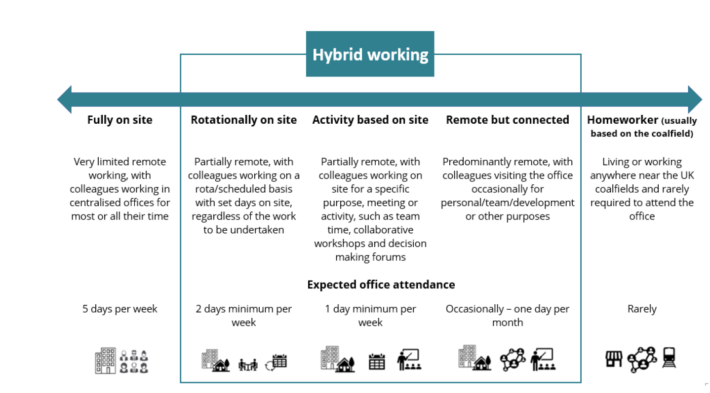

Person specification

Job Title: | Project Manager - Innovation By-Products and Service Delivery |  | Department: |  | Innovation, By-Product and Services Delivery
 | Essential |  | Desirable
Qualifications and Training | - Educated to Degree level or with equivalent experience  - Desire to continue to learn and develop professionally |  | - A project management qualification (e.g. APM/PMI, MSP or PRINCE2) or willingness to work towards this or equivalent Lifecycle process experience.  - Site Management Safety Training Scheme (SMSTS)
Experience and Knowledge | - Proven ability to innovate or support delivery of innovative solutions  - Experience in application of commercial concepts  - Experience delivering projects with medium to high complexity |  | - Experience of the water industry, energy sector, mining or environmental / land remediation consultancy.  - Water sector experience is especially relevant.  - Experience delivering a variety of projects  - Some experience of site monitoring, testing or sampling  - Some knowledge of best practice procurement
Skills and Abilities | - Able to manage programmes/projects  - Able to engage and communicate effectively with project and non-project people at every level  - Proven understanding of Project, Programme and Portfolio Management principles, tools and techniques  - Analytical and reporting skills  - Clear and concise presentation skills  - Methodical and organised  - Skilled using MS Office and other software to support project management |  | - Able to lead programmes/projects  - Able to facilitate and produce project schedules  - Able to facilitate workshops  - Some experience using MS Project or MS Project Web App (PWA)
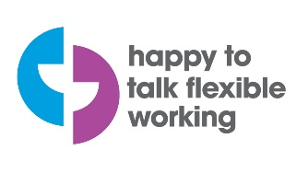 |  | 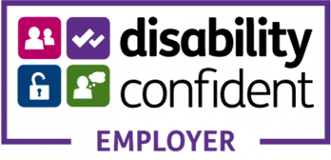 |  | 

