Job Title: | Community Incident & Support Account Manager
Department: | Community Incident Management and Support
Reports to: | Principle Community Incident and Support Manager
Direct Reports: | N/A
Location: | Activity Based On Site
Contract Type: | Temporary
Grade: | 5

Main purpose of the job

As an Incident Account Manager, you’ll act as a trusted point of contact for a defined portfolio of residents and community representatives during incident response, taking accountability for maintaining strong relationships and making sure their needs, concerns and priorities are understood. You’ll help keep communication clear, timely and focused when issues arise, building confidence before, during and after incidents so residents feel informed, supported and assured in the service being provided.

You’ll work closely with operational teams, residents, partners and internal colleagues to understand resident needs, manage expectations and ensure the right information reaches the right people at the right time. You’ll help translate technical or operational updates into clear, practical messages that support decision making and maintain trust.

A strong understanding community relationship management, community support and incident response ways of working will be key. By developing meaningful relationships and staying calm under pressure, you’ll help make sure residents receive a consistent, professional and empathetic experience throughout an incident lifecycle.

Responsibilities

Specific
- Build and maintain strong, trusted relationships with residents so they feel supported, listened to and confident in the response being delivered.
- Take accountability for managing a defined portfolio of residents, understanding their needs, concerns and priorities so incident response activity is tailored, timely and effective.
- Act as a clear point of contact for residents during incidents, helping to coordinate updates, capture concerns and ensure expectations are managed appropriately.
- Work closely with operational, technical and customer facing teams to understand the impact of incidents and communicate progress in a way that is clear, accurate and meaningful to residents.
- Prepare and share timely resident updates, briefings and follow-up actions, making sure communication is consistent and aligned with the wider incident response approach.
- Work closely with the incident customer service advisors to share resident insight, align messaging and ensure customers receive a joined-up, consistent and supportive experience throughout an incident.
- Use feedback from residents to identify themes, risks and opportunities to improve the incident response experience and strengthen future ways of working.
- Demonstrate an ability to remain calm, empathetic, professional and solutions-focused when dealing with sensitive, urgent or complex resident issues.
- Support post-incident reviews by gathering resident feedback, sharing lessons learned and helping to turn agreed actions into practical service improvements.
- Maintain a clear understanding of resident priorities, service commitments and escalation routes so incidents are handled with the right level of urgency and care.
- Identify where vulnerable residents may need additional support and prioritise.
- Identify wider value from strong resident management, including improved confidence, reduced reputational risk, better collaboration and a smoother customer journey during challenging situations.

General
- Act in line with the behaviours and values of the organisation.
- Manage your own performance to be accountable for meeting individual, team and corporate objectives.
- Act in accordance with the Scheme of Delegation and ensure propriety and regularity in the handling of public funds.
- Actively demonstrate the Mining Remediation Authority’s customer service standards expected of your role.
- Follow and contribute to the improvement of operational and team processes and procedures.
- Assist with the preparation and delivery of the team’s objectives, budgets and financial records.
- Identify opportunities and implement change leading to team development, system. improvement and ensuring good value for money.
- Maintain and develop positive stakeholder relationships in order to promote the Authority and assist it to meet its objectives.
- Support research and development projects.
- Ensure that the Authority’s statutory responsibilities are effectively discharged.
- Carry out any further reasonable requests from your line manager.

Values in Action
We expect all our colleagues to embody our core values and behaviours in their daily work.
Trusted
- We act with integrity
- We’re open and transparent
- We deliver on our commitments
Inclusive
- We promote a culture of mutual respect
- We recognise that our differences make us stronger
- We work with others to achieve our vision
Progressive
- We’re open minded and innovative
- We recognise that the past can help us shape the future
- We listen and learn
Our Values in Action framework outlines important behavioural indicators which help us demonstrate our values through our work together.
Hybrid Working Model
This role sits within our Hybrid Working Model. The designated hybrid arrangement for this post is outlined under “Location” on page 1 of this Job Description and reflects the requirements of the role and the organisation. Hybrid working arrangement be reviewed and adjusted if business needs change.

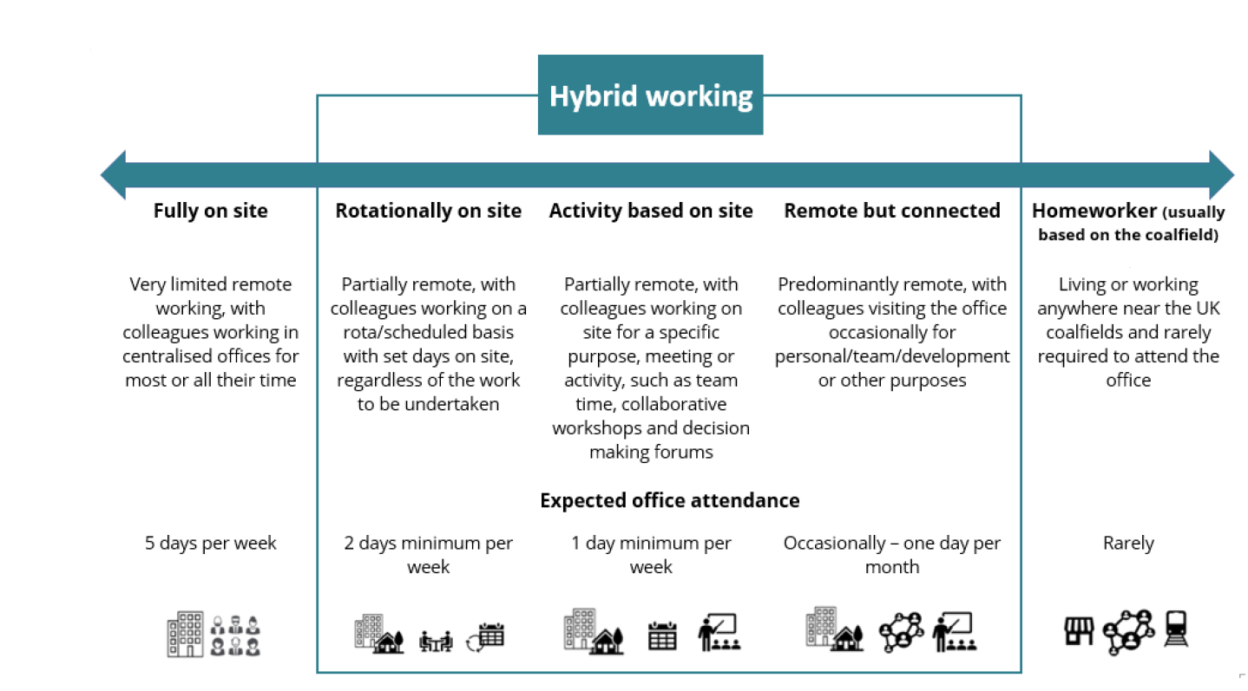

Person specification

Job Title: Community Support Account Manager |  |  | Department: Community and Incident Response
 | Essential |  | Desirable
Qualifications and Training | - No minimum qualification set if candidate can demonstrate relevant experience required for the role  - GCSEs at Grade C and above to include English and Maths |  | - Degree or relevant further education qualification
Experience and Knowledge | - Previous experience of managing resident or customer relationships in a service delivery, account management or operational environment  - Experience of supporting residents during high-pressure situations  - Experience of preparing clear written and verbal updates for different audiences  - Experience of using Microsoft Office products to record actions, track progress and support resident reporting including Microsoft Teams and Excel |  | - Experience of supporting residents during incidents.
Skills and Abilities | - Strong resident and account management skills  - Clear, confident and empathetic communication skills, especially when sharing updates.  - Ability to remain calm under pressure and manage sensitive conversations professionally  - Ability to prioritise tasks, manage competing resident needs and work to tight deadlines  - Ability to work collaboratively with operational, technical and customer facing teams  - Strong customer focus and commitment to providing a consistent, high-quality resident experience  - Good judgement, attention to detail and ability to share accurate information at pace
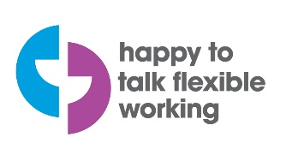 |  | 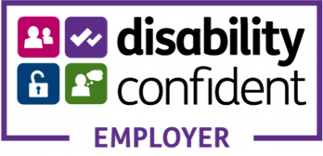 |  | 