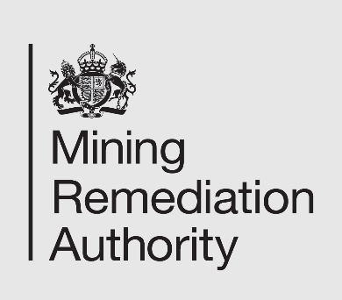

Job Title: Principal Property Manager – Salinity
Department: Salinity – Commercial Delivery
Reports to: Head of Commercial Delivery - Salinity
Direct Reports: 2 Property Managers
Grade: CA5+

Main purpose of the job

- To provide strategic oversight of land and property rights acquisition, interests and compensation activities, developing the capability, processes and governance required to support programme delivery.
- To act as senior delivery lead for specific aspects of the programme (including assurance and governance) inputting to/leading on the development of Programme budgets, strategies and plans.
- To acquire the necessary property rights required to meet the operational needs of all aspects of the Salinity Programme.
- To provide support and assistance to the Head of Programme Delivery in overall delivery of the Salinity Programme.
- To liaise with the Development Property Team to ensure, where appropriate, consistency of approach, processes and governance across the organisation.

Responsibilities

Specific
- To work alongside the Head of Programme Delivery to identify key areas of focus and to set direction for the team.
- To develop a team framework to facilitate the effective delivery of the acquisition of land and property rights and interests in connection with work streams forming part of the Programme.
- To recruit a high-quality team, as and when required, to deliver all of the property needs for all aspects of the Programme.
- To oversee and support the timely acquisition of all permanent and temporary land and property rights and interests required for programme delivery, securing best value for taxpayers and ensuring full compliance with The Mining Remediation Authority land transaction governance and approval processes.
- To work closely with Stakeholder Management specialists and systems and manage all aspects of external stakeholder engagement in relation to the acquisition of property rights and any associated compensation payments.
- To procure and manage, via an appropriate process and delivery model, external specialist consultants, when required, to support delivery of the Programme generally and on specific aspects of land rights acquisition and compensation management needs relating to the Programme.
- To support the preparation, development and submission of relevant business case approvals, ensuring land and property requirements are appropriately represented and evidenced.
- To work with internal stakeholders such as technical, property, legal, procurement, HSW etc. with regards to programme delivery.
- To work closely with the Development Department Property Team to share best practice, avoid duplication and to ensure all processes and systems relating to property matters are standardised across both departments.

General

- Act in line with the behaviours and values of the organisation.
- Manage your own performance to be accountable for meeting individual, team and corporate objectives.
- Act in accordance with the Scheme of Delegation and ensure propriety and regularity in the handling of public funds.
- Actively demonstrate the Mining Remediation Authority’s customer service standards expected of your role.
- Follow and contribute to the improvement of operational and team processes and procedures.
- Assist with the preparation and delivery of the team’s objectives, budgets and financial records.
- Identify opportunities and implement change leading to team development, system improvement and ensuring good value for money.
- Maintain and develop positive stakeholder relationships in order to promote the Authority and assist it to meet its objectives.
- Support research and development projects.
- Ensure that the Authority’s statutory responsibilities are effectively discharged.
- Carry out any further reasonable requests from your line manager.
Values in Action
We expect all our colleagues to embody our core values and behaviours in their daily work.
Trusted
- We act with integrity
- We’re open and transparent
- We deliver on our commitments

Inclusive
- We promote a culture of mutual respect
- We recognise that our differences make us stronger
- We work with others to achieve our vision

Progressive
- We’re open minded and innovative
- We recognise that the past can help us shape the future
- We listen and learn
Our Values in Action framework outlines important behavioural indicators which help us demonstrate our values through our work together.

Hybrid Working Model
This role sits within our Hybrid Working Model. The designated hybrid arrangement for this post is outlined under “Location” on page 1 of this Job Description and reflects the requirements of the role and the organisation. Hybrid working arrangements may be reviewed and adjusted if business needs change.
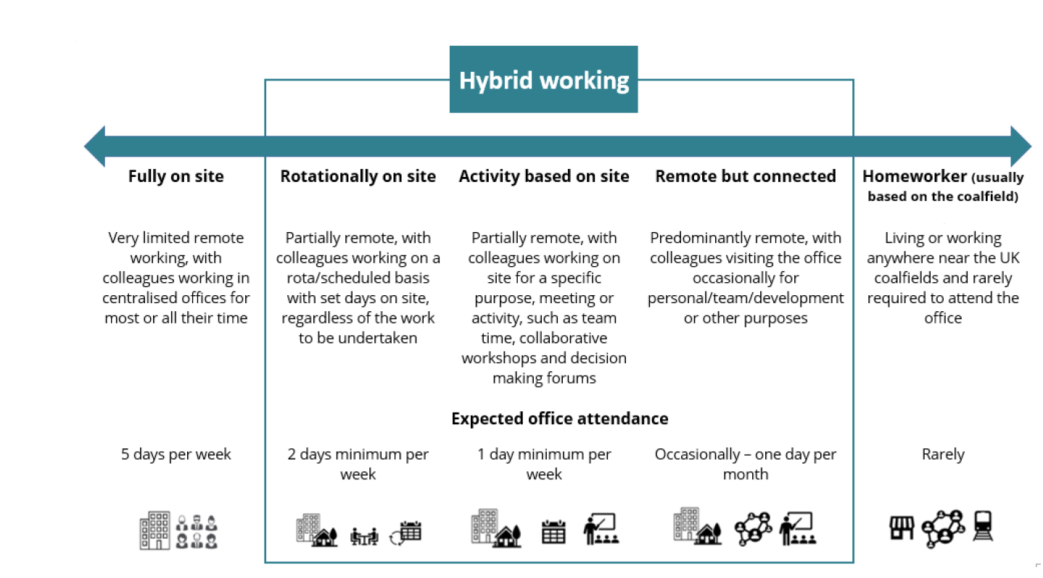

Person specification

Job Title: Principal Property Manager |  | Department: Salinity
 | Essential |  | Desirable
Qualifications and Training | - Degree or equivalent and Member or Fellow of the Royal Institution of Chartered Surveyors (RICS) |  | - MBA/MSc  - Membership of Compulsory Purchase Association  - Membership of The Central Association of Agricultural Valuers  - RICS Registered Valuer
Experience and Knowledge | - Experience in building and managing teams of professionals  - Extensive post-qualification experience in Property/ land management and development  - Extensive experience in acquiring leaseholds, freeholds, easements, licences, temporary access etc. in a commercial, central or local government environment  - Experience in contract management  - Experience in budget management and forecasting  - Change management  - Experience of dealing with complex stakeholder issues.  - Experience of complex consenting processes, planning, EIAs etc. |  | - Experience in a minerals/ mining industry or construction field  - Experience working on major infrastructure projects and particularly large, linear infrastructure projects  - Knowledge of Nationally Significant Infrastructure Projects and the Development Consent Order process  - Experience/ working knowledge of Compulsory Purchase processes/acting on behalf of acquiring authorities or vendors/claimants  - NEC family of contracts  - Experience in delivering complex environmental improvement projects.
Skills and Abilities | - Excellent and proven negotiation skills  - Highly commercially astute  - Leadership, line management & team motivational skills  - Excellent report writing skills  - Excellent written and communication skills  - Ability to deal with a high-volume detailed workload and prioritisation  - Good interpersonal and managerial skills  - Financial and programme management skills |  | - Leadership/management training
Other | - Extended working hours  - Field visits  - Overnight stays  - Significant travel  - Use of PPE |  | - Flexible working hours  - Hybrid working


