Job Title: | Head of Project Delivery - Coal
Department: | Environment Delivery - Coal
Reports to: | Environment Director
Direct Reports: | Principal Programme Manager x1, Administration Officer x 1
Location: | Activity Based On Site
Contract Type: | Permanent
Grade: | CA6

Main purpose of the job

To lead the Project Delivery Team to achieve the objectives of the Mining Remediation Authority strategy and corporate plan, including:
- Leading a team of project and programme management professionals to deliver the capital investment programme for the Mining Remediation Authority.
- Provide oversight, governance and senior stakeholder management to ensure effective delivery of projects across the coal programme for both internal and external clients.
- Be accountable for the delivery of the programme to the stated objectives, on time and within budget.
- Be an active member of the Environment Directorates senior leadership team assisting in the delivery of continuous improvement, performance and forward strategy across the directorate and the Mining Remediation Authority.

Responsibilities

Specific
- Provide senior leadership and strategic direction to the projects delivery team.
- To lead and develop the team, ensuring it has the right balance of skills and experience to deliver its objectives.
- Manage and be accountable for the delivery of the Mining Remediation Authority’s capital investment programmes, made up of multiple projects primarily relating to the control and management of mine water.
- Manage and have budget responsibility for a capital budget of £20 - £30M per year.
- Ensure delivery outputs and spend are accurately monitored and reported through senior stakeholders.
- Ensure all projects are delivered and managed in accordance with Mining Remediation Authority procedures and governance framework.
- Ensure the projects are delivered to help achieve the Mining Remediation Authority’s objectives around sustainability, taking a catchment-based approach and delivering multiple outcomes.
- Manage internal relationships with key stakeholders such as the Environment Operations department who will act as your internal client and end user on many projects.
- Manage key relationships within internal delivery teams such as Property, Planning, Engineering, and Procurement who will support in project delivery.
- Manage the external supply chain to ensure it supports the delivery needs of the team and the programmes.
General
- Act in line with the behaviours and values of the organisation.
- Manage your own performance to be accountable for meeting individual, team and corporate objectives.
- Act in accordance with the Scheme of Delegation and ensure propriety and regularity in the handling of public funds.
- Actively demonstrate the Mining Remediation Authority’s customer service standards expected of your role.
- Follow and contribute to the improvement of operational and team processes and procedures.
- Assist with the preparation and delivery of the team’s objectives, budgets and financial records.
- Identify opportunities and implement change leading to team development, system. improvement and ensuring good value for money.
- Maintain and develop positive stakeholder relationships in order to promote the Authority and assist it to meet its objectives.
- Support research and development projects.
- Ensure that the Authority’s statutory responsibilities are effectively discharged.
- Carry out any further reasonable requests from your line manager.

Values in Action
We expect all our colleagues to embody our core values and behaviours in their daily work.
Trusted
- We act with integrity
- We’re open and transparent
- We deliver on our commitments
Inclusive
- We promote a culture of mutual respect
- We recognise that our differences make us stronger
- We work with others to achieve our vision
Progressive
- We’re open minded and innovative
- We recognise that the past can help us shape the future
- We listen and learn
Our Values in Action framework outlines important behavioural indicators which help us demonstrate our values through our work together.
Hybrid Working Model
This role sits within our Hybrid Working Model. The designated hybrid arrangement for this post is outlined under “Location” on page 1 of this Job Description and reflects the requirements of the role and the organisation. Hybrid working arrangements may be reviewed and adjusted if business needs change.
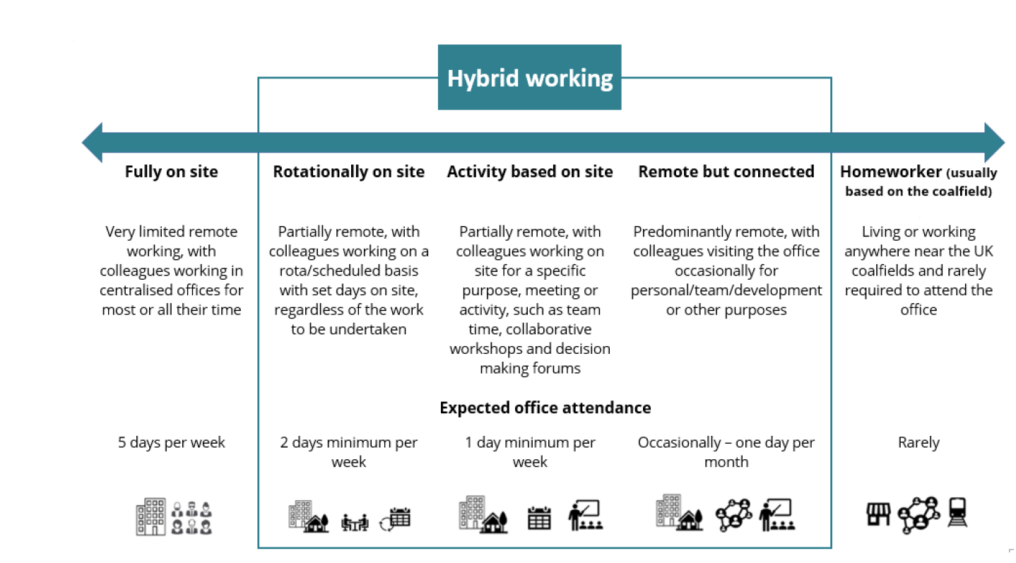

Person specification

Job Title: | Head of Project Delivery - Coal |  | Department: |  | Environment Delivery - Coal
 | Essential |  | Desirable
Qualifications and Training | - Degree level qualification in engineering or related field, or extensive demonstrable experience.  - Project and programme management qualification/training |  | - Corporate membership of a relevant professional body.  - Leadership qualification  - MSP/MoP qualified
Experience and Knowledge | - Significant experience of project and programme delivery (10+ years) preferably in a civil engineering/infrastructure/water management environment.  - Budget management  - Experience of managing a delivery team  - Supply chain & framework management  - Basic NEC contract management  - Working knowledge of Health, Safety and Environmental issues  - Experience of managing senior stakeholders |  | - Environmental Legislation  - NEC contract management accreditation  - Experience in a mining liabilities and /or construction field  - Experience in mine water remediation
Skills and Abilities | - Exceptional leadership and team development skills  - Exceptional stakeholder management  - Good negotiation skills  - Excellent written, communication and presentation skills  - Ability to deal with a high-volume detailed workload and prioritisation  - Good interpersonal and managerial skills
Other | - Field visits to remote and difficult access sites  - Overnight stays  - Use of PPE  - Valid UK Driving Licence
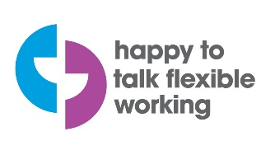 |  | 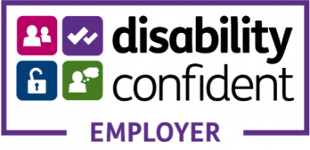 |  | 

