Job Title: | Project Manager (Metal Mines)
Department: | Environment
Reports to: | Programme Lead Metal Mines
Direct Reports: | Up to 1
Location: | Activity Based On Site
Contract Type: | Permanent
Grade: | 5

Main purpose of the job

Working with an allocated portfolio of projects and/or geographic area.
- As project manager on work to progress mine water prevention and treatment scheme projects from identification, feasibility, concept, through detailed design to subsequent construction and commissioning.
- As project manager on work to deliver efficiency, refurbishment, R&D and any other projects identified.
- Develop and manage project programmes, risk register and contracts.
- Use skills to lead and manage multi-disciplinary specialists to deliver projects at pace to agreed timescales whilst ensuring cost saving initiatives, innovation, collaboration and openness are considered.

Responsibilities

Specific
- To commission and project manage scoping, feasibility investigations to deliver the specification for a design and build contracts to enable schemes to be implemented to prevent and reduce mine water pollution.
- To commission and lead other projects e.g. efficiency improvements, scheme refurbishment, R&D as required.
- To be responsible and accountable for the project budget from inception through to operation and project close for contracts with capital values of up to £20M, ensuring projects have agreed objectives and milestones and that they are managed to time and to cost.
- To monitor actual and financial progress of each project and advise the Principal Programme Manager of any significant variances.
- To develop, maintain and manage project programmes to effectively deliver projects, advising managers of change through the project. Planning internal resource through the project programmes.
- Manage change through the project’s life in accordance with procedures and the Scheme of Delegation.
- Manage supplier contracts, primarily NEC PSC and ECC contracts to ensure the supply chain delivers to the agreed quality, time and budget. Escalating any performance issues to managers.
- Promote “best practice” through learning from completed schemes and industry development. Including working with the Project Management Office to develop and amend standards and guidance.
- To liaise with the Principal Contracts Manager during the Design/Build and Operations phases of the allocated treatment systems on technical issues.
- To ensure effective communication with managers on allocated projects to ensure issues are identified and resolved to ensure smooth transition into design and build, and thereafter into operation.
- To commission services of consultants and contractors to ensure scheme progress and then manage and hold accountable for delivery. Performance management including KPI’s.
- To engage and work with other internal teams with the Authority to define project objectives and outcomes and seek input from these teams throughout the project.
- To challenge designs, concepts and reports.
- To liaise with relevant third parties/stakeholders including local authorities, regulators, landowners and members of the public.
- To prepare and update the Business Case for projects and other supporting documents in accordance with guidance to to allow decision makers to provide assurance through the project. Including reporting on expenditure above authorised limit including variation orders/compensation events arising.
- To mentor and coach less experienced members of staff.
Prepare and present reports on progress and outcomes of projects including monthly reports, financial management, investment board papers, MP letters and stakeholder letters.

General
- Act in line with the behaviours and values of the organisation.
- Manage your own performance to be accountable for meeting individual, team and corporate objectives.
- Act in accordance with the Scheme of Delegation and ensure propriety and regularity in the handling of public funds.
- Actively demonstrate the Mining Remediation Authority’s customer service standards expected of your role.
- Follow and contribute to the improvement of operational and team processes and procedures.
- Assist with the preparation and delivery of the team’s objectives, budgets and financial records.
- Identify opportunities and implement change leading to team development, system. improvement and ensuring good value for money.
- Maintain and develop positive stakeholder relationships in order to promote the Authority and assist it to meet its objectives.
- Support research and development projects.
- Ensure that the Authority’s statutory responsibilities are effectively discharged.
- Carry out any further reasonable requests from your line manager.

Values in Action
We expect all our colleagues to embody our core values and behaviours in their daily work.
Trusted
- We act with integrity
- We’re open and transparent
- We deliver on our commitments
Inclusive
- We promote a culture of mutual respect
- We recognise that our differences make us stronger
- We work with others to achieve our vision
Progressive
- We’re open minded and innovative
- We recognise that the past can help us shape the future
- We listen and learn
Our Values in Action framework outlines important behavioural indicators which help us demonstrate our values through our work together.

Hybrid Working Model
This role sits within our Hybrid Working Model. The designated hybrid arrangement for this post is outlined under “Location” on page 1 of this Job Description and reflects the requirements of the role and the organisation. Hybrid working arrangements may be reviewed and adjusted if business needs change.
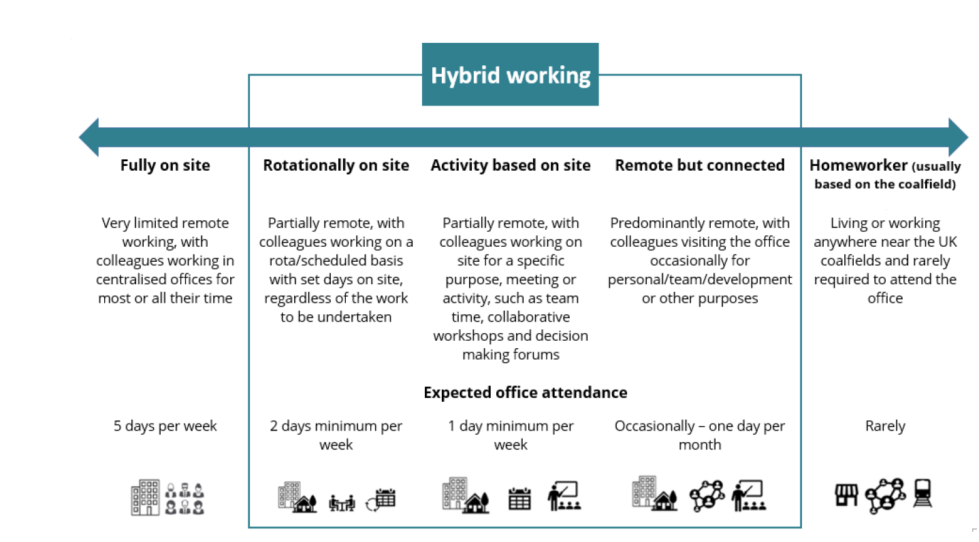

Person specification

Job Title: | Project Manager (Metal Mines) |  |  | Department: | Environmental
 | Essential |  |  | Desirable
Qualifications and Training | - No minimum qualification set if candidate can demonstrate relevant experience as required in the role |  |  | - Degree or equivalent together with corporate membership of a relevant professional body
Experience and Knowledge | - Experience of dealing with contractors, members of the public, MPs  - Experience of managing conditions of contract  - Experience in the Project Management of the development and build of civil engineering projects |  |  | - Experience of significant civil engineering and earth moving projects  - Experience of managing
Skills and Abilities | - Project Management  - Report writing skills  - Negotiation skills  - Supervisory skills  - Interpersonal skills  - Financial monitoring and control  - Ability to deal with sustained and high workloads  - Working to tight deadlines
Other
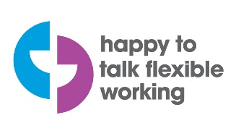 |  |  | 

