Job Title: | Earth Scientist
Department: | Technical Services
Reports to: | Technical Programme Lead – Inland Salinity
Direct Reports: | None
Location: | Activity Based On Site
Contract Type: | Temporary
Grade: | CA5

Main purpose of the job

To provide technical leadership on projects within the Inland Saline Mine Water Programme, working to mitigate the risk of environmental pollution associated with mine water rebound across the coalfields of Great Britain.
To work with internal specialists and external consultants to acquire, analyse and evaluate geoscientific data, and develop studies and solutions relating to the management of rising saline mine water.
Responsibilities

Specific
- To act as a technical specialist within the Inland Saline Mine Water Programme, supporting the development and implementation of strategies to assess and manage saline mine waters.
- To develop and maintain a detailed knowledge and conceptual understanding of the mine water recovery status across the coalfields, identifying emerging risk areas and advising where intervention may be required.
- To collate, analyse and interpret environmental monitoring data from the Mining Remediation Authority, external contractors and third parties, identifying trends and assessing environmental risks associated with rising saline mine water.
- To prepare technical reports and critically review reports produced by others.
- To work with external consultants and internal technical teams to scope, manage and deliver technical studies, using hydrogeological and geochemical evidence to inform mine water management strategies.
- To coordinate and oversee contractor deliverables, ensuring information is provided accurately, in the agreed format and to the required quality standards and timescales.
- To communicate technical project progress and outcomes to the wider programme team.
- To work with external partners and regulators to support programme delivery, including environmental permitting and compliance activities.
- To provide technical input into the phasing and requirements of future interventions including borehole design, test pumping and monitoring.
- To provide regular technical reporting and GIS-based analysis on pumping test metrics, treatment trials, environmental monitoring and related activities.
- To undertake site visits across the UK to oversee borehole drilling, downhole logging and survey works, install and maintain monitoring equipment, and collect additional field data as required.
- To evaluate desalination and other water treatment technologies, assessing their feasibility and application to UK coal mine waters.
- To respond promptly and accurately to requests for information.
General
- Act in line with the behaviours and values of the organisation.
- Manage your own performance to be accountable for meeting individual, team and corporate objectives.
- Act in accordance with the Scheme of Delegation and ensure propriety and regularity in the handling of public funds.
- Actively demonstrate the Mining Remediation Authority’s customer service standards expected of your role.
- Follow and contribute to the improvement of operational and team processes and procedures.
- Assist with the preparation and delivery of the team’s objectives, budgets and financial records.
- Identify opportunities and implement change leading to team development, system. improvement and ensuring good value for money.
- Maintain and develop positive stakeholder relationships in order to promote the Authority and assist it to meet its objectives.
- Support research and development projects.
- Ensure that the Authority’s statutory responsibilities are effectively discharged.
- Carry out any further reasonable requests from your line manager.

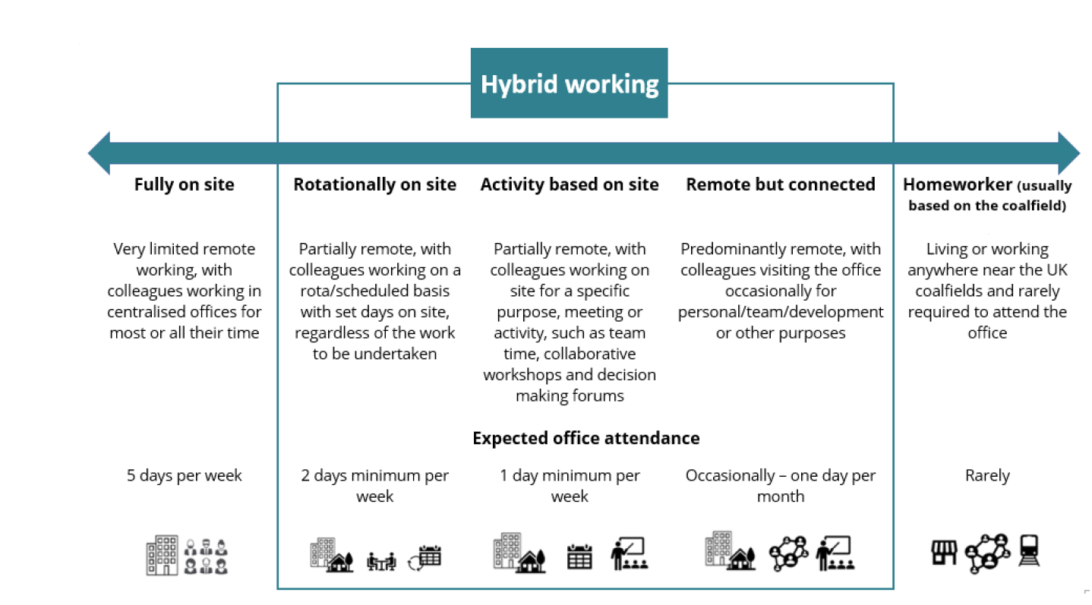
Values in Action
We expect all our colleagues to embody our core values and behaviours in their daily work.
Trusted
- We act with integrity
- We’re open and transparent
- We deliver on our commitments
Inclusive
- We promote a culture of mutual respect
- We recognise that our differences make us stronger
- We work with others to achieve our vision
Progressive
- We’re open minded and innovative
- We recognise that the past can help us shape the future
- We listen and learn
Our Values in Action framework outlines important behavioural indicators which help us demonstrate our values through our work together.

Hybrid Working Model
This role sits within our Hybrid Working Model. The designated hybrid arrangement for this post is outlined under “Location” on page 1 of this Job Description and reflects the requirements of the role and the organisation. Hybrid working arrangements may be reviewed and adjusted if business needs change.

Person specification

Job Title: | Earth Scientist |  | Department: |  | Technical Services
 | Essential |  | Desirable
Qualifications and Training | - Bachelors degree in Earth Science related subject. |  | - MSc in Earth Science related subject.  - Chartered status or progression towards this.
Experience and Knowledge | - Demonstrable experience of taking responsibility for earth science projects or technical studies, using professional judgement to develop recommendations and manage delivery through others.  - Working as a technical lead for earth science projects/ programmes.  - Ability to define and conceptualise technical problems and scope appropriate technical studies and solutions.  - Supervision and management of contractors and consultants to deliver technical work. |  | - Track record of technical project management.  - Coal measures geology and/or UK coal mine workings and mine water expertise.  - Water quality, hydrogeological risk assessment and saline groundwater project experience.  - Knowledge of regulations relating to the water environment and Construction Design Management.  - Collaborative working with partner organisations and stakeholders.  - Experience in borehole siting, drilling supervision, and pumping test delivery.  - Understanding of public sector procurement procedures.
Skills and Abilities | - Demonstrable ability to explain and support technical recommendations with evidence, constructively challenge alternative views and influence colleagues, consultants and external partners.  - Problem solving and innovative thinking.  - Ability to work under pressure and be flexible.  - Excellent communication and interpersonal skills.  - Excellent time management and prioritisation skills.  - Excellent IT skills.  - Ability to interpret hydrogeological and geochemical data.  - Good technical report writing and review.  - Good GIS data processing and reporting. |  | - Use of hydrogeological and geochemical software packages.  - Hydrogeological or geochemical modelling experience.  - Ability to interpret UK coal mine abandonment plans
Other | - Full UK valid driving licence.  - Site visits across the UK (predominantly in Yorkshire and the East Midlands).  - Occasional nights away from home, up to two times per month.
 |  |  |  | 

