Job Title: | Contracts Manager - Commercial
Department: | Salinity
Reports to: | Principal Commercial Manager
Direct Reports: | None
Location: | Activity Based On Site
Contract Type: | Permanent
Grade: | CA5

Main purpose of the job

- Develop the Authority’s commercial function by supporting and leading procurement activities for:
  - consultancy services required for technical support and analysis relating to rising mine water, and
  - contractors for minor and major civil works (asset refurbishment / new boreholes).
- Delivering progressive contract management for live contracts ensuring both the Authority and supply chain are acting within the confines of the contract.
- Designing and implementing procurement and contracting strategies (NEC PSC & ECC + bespoke T&Cs occasionally), ensuring consistent documentation, with the aim of protecting the Authority from commercial and contractual risk.
- Promoting collaborative behaviours with supply chain partners and acting as a trusted advisor to Project Managers through scoping, early market engagement, tendering, Early Contractor Involvement (ECI).
- Providing robust commercial assurance so that every package goes to market aligned with project objectives, governance, and best practice.
This role is part of the commercial function within the Inland Saline Mine Water Programme. The team includes the Cost Manager, Principal Commercial Manager, who is the line manager for this role, and Head of Commercial Delivery. Together, the team is responsible for delivering the programme’s Commercial Strategy. The role also works closely with the Principal Procurement Business Partners to ensure compliance with relevant regulations and governance approval processes.
Responsibilities

Specific
Strategy & Governance
- Support and lead in the development of the pre-construction commercial strategy, including procurement route selection (e.g. two-stage tendering, frameworks, open/limited competition) aligned to programme objectives, budget, risk profile, market conditions, and governance requirements.
- Produce and maintain the commercial strategy & procurement plan, decision papers, approvals, and audit trail in line with internal governance.
- Recommend appropriate NEC contract forms (PSC/ECC), main options (e.g. A, C, E), secondary options (e.g. X18 Limitation of Liability, X22 ECI), and writing of bespoke Z-clauses—ensuring consistency and avoiding ambiguities across all documentation.
Tender Development & Market Engagement
- Working with the project teams lead and oversee drafting of all tender documentation: ITT, Scope, Site Information, Contract Data, pricing schedule/Bill of Quantities, evaluation methodology, and clarification protocols.
- Support/Plan and run two-stage tendering and Early Contractor Involvement (ECI) processes (e.g. pre-construction services, collaborative value engineering, risk workshops), ensuring transparency and value.
- Support in general and/or early market engagement through structured requests for information / soft-market testing, supplier days, and early collaboration to build supply chain understanding and relationships.
Evaluation, Negotiation & Award
- Support and commercially lead the preparation, evaluation, moderation, and award of tender packages, ensuring evaluation criteria and scoring are applied consistently and fairly.
- Conduct commercial negotiations, protect client risk positions (price, programme, liability, insurances, warranties, intellectual property rights, inflation), and secure robust contract terms while maintaining collaborative relationships.
- Support in the production of clear award recommendations, approvals, standstill and debrief materials.
Contract Creation, Review & Assurance
- Draft, review, and finalise NEC PSC/ECC contracts (including Contract Data, Scope, Site Information, Z-clauses), ensuring alignment between all documents and removal/correction of ambiguities and inconsistencies.
- Provide contract form advice and support to project teams; ensure obligations, communications, and mechanisms (compensation events, risk registers, early warnings) are understood and practicable.
- Establish document control standards and consistency checks (templates, clause libraries, terminology guidance).
Risk & Opportunity Management
- Identify, assess, and manage commercial risks across packages (risk allocation, pricing strategy, inflation, ground conditions, design development, interfaces, third-party consents).
- Support risk workshops; ensure risks are properly owned, mitigated, or priced; track opportunities and efficiencies during the pre-construction period (innovation, modern methods of construction, carbon reduction, programme savings).
Client Protection & Collaboration
- Balance risk protection (clear obligations, limits of liability, security/insurances, performance regimes) with collaborative delivery, striving to be an “intelligent client”: fair allocation of risk, timely decisions, and transparent communications.
- Promote commercial excellence and continuous improvement across the team—share best practice, lessons learned, and standardise approaches.
Stakeholder Support
- Support Project Managers to ensure all documents are complete, consistent and issued on time; advise on clauses and terminology.
- Coach and support less experienced team members on NEC obligations, drafting and evaluations; provide accessible guidance materials.
- Collaborate with internal teams (Project Management, Tech team, Engineering/Design, H&S/CDM, Innovation, Environment Finance, Legal, Sustainability) to ensure holistic, compliant solutions.
Systems & Reporting
- Maintain commercial records, approvals, and audit trails using corporate systems (SharePoint/Teams/Aconex).
- Report pre-construction status, risks, and upcoming decisions; maintain dashboards for gateways, approvals and tender timelines.
- Report contractor and Authority performance against KPIs.
General
- Act in line with the behaviours and values of the organisation.
- Manage your own performance to be accountable for meeting individual, team and corporate objectives.
- Act in accordance with the Scheme of Delegation and ensure propriety and regularity in the handling of public funds.
- Actively demonstrate the Mining Remediation Authority’s customer service standards expected of your role.
- Follow and contribute to the improvement of operational and team processes and procedures.
- Assist with the preparation and delivery of the team’s objectives, budgets and financial records.
- Identify opportunities and implement change leading to team development, system. improvement and ensuring good value for money.
- Maintain and develop positive stakeholder relationships in order to promote the Authority and assist it to meet its objectives.
- Support research and development projects.
- Ensure that the Authority’s statutory responsibilities are effectively discharged.
- Carry out any further reasonable requests from your line manager.

Values in Action
We expect all our colleagues to embody our core values and behaviours in their daily work.
Trusted
- We act with integrity
- We’re open and transparent
- We deliver on our commitments
Inclusive
- We promote a culture of mutual respect
- We recognise that our differences make us stronger
- We work with others to achieve our vision
Progressive
- We’re open minded and innovative
- We recognise that the past can help us shape the future
- We listen and learn
Our Values in Action framework outlines important behavioural indicators which help us demonstrate our values through our work together.
Hybrid Working Model
This role sits within our Hybrid Working Model. The designated hybrid arrangement for this post is outlined under “Location” on page 1 of this Job Description and reflects the requirements of the role and the organisation. Hybrid working arrangements may be reviewed and adjusted if business needs change.
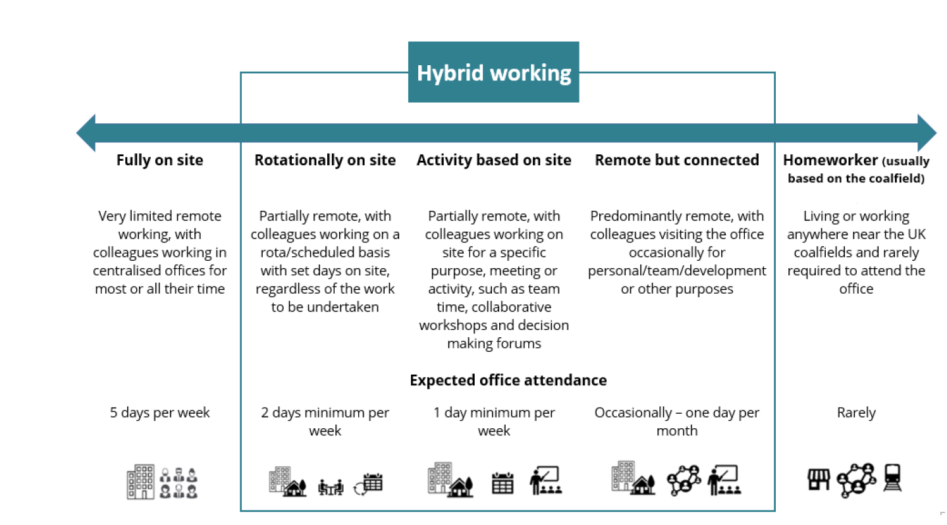

Person specification

Job Title: | Contracts Manager - Commercial |  | Department: |  | Salinity
 | Essential |  | Desirable
Qualifications and Training | - NEC Training (e.g. NEC4 PSC/ECC fundamentals). |  | - NEC Accreditation (e.g. NEC4 ECC Project Manager / Service Manager, or NEC Accredited Practitioner.)  - Quantity Surveying qualification highly desirable (e.g. BSc QS/Commercial Management).
Experience and Knowledge | - Substantial hands-on experience of working with NEC contracts, particularly NEC4 PSC and/or ECC. This includes practical experience of management of contract drafting, review, and creation; evaluation and award of packages; advisory on options and secondary clauses (including X22).  - Procurement experience (strategy, route selection, evaluation methodologies, moderation and award). |  | - UK Procurement Governance and Regulations.  - Two-stage tendering & ECI: delivering collaborative pre-construction services, value engineering and risk management to agreed cost/quality targets.  - Track record of client-side delivery: strong governance, assurance, and documentation consistency; protecting client interests while building trusted relationships with suppliers.  - Experience supporting cross-departmental teams and coaching less experienced colleagues.  - Sector experience in complex infrastructure, remediation, environmental or industrial projects.
Skills and Abilities | - Excellent analytical and negotiation skills: pricing assessments, cost benchmarking, commercial modelling, negotiation of terms and clarifications.  - Contract drafting - NEC Scope, Contract Data, Z-clauses; ensuring cross-document alignment and terminology consistency.  - Procurement design - route selection, evaluation design, scoring matrices; moderation fairness and auditability.  - Commercial risk assessment: risk registers, risk allocation strategies, compensation event mechanics, change control.  - Stakeholder engagement - able to build trusted relationships, facilitate workshops, and communicate complex issues clearly. |  | - Continuous improvement mindset - standardisation, templates, lessons learned, and capability development.  - Advanced MS Excel/Word, and NEC contract administration platforms (e.g. Aconex) experience.  - High attention to detail - strong written presentation; structured thinking; resilience under time pressure.
Other
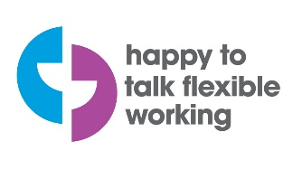 |  |  |  | 

